We look forward to welcoming you to

ASHRIDGE PARK F.C.

Fixture information for visiting teams

Date and Kick Off time
Saturday xx:00am kick off
Away Team
Barcelona
League
We will be playing on Pitch X
Home Team Colours
Blue & White stripes, with blue shorts and socks
Coach contact details
Mr Ash Ridge 0xxxx xxxxxx
Referee
Xxx xxx: Please bring half of the referee fee; £xx per team
Venue Address
St Crispins School, London Road, Wokingham RG40 1SR

Respect Guidelines:
Ashridge Park implements spectator barriers beside all of the pitches in accordance with the RESPECT Programme. We respectfully ask that all spectators enjoy the match from behind those lines, observe the code of conduct by being positive & encouraging to all the players in the game and to respect the referee’s decisions.
Head Injuries
We require all teams to adhere to FA guidelines on head injuries
Photography:
We allow photography of our games at Ashridge Park; if you do NOT wish photographs to be taken at the game then please inform the Ashridge Park coaches beforehand.

Pitch Layout
(Not to scale)
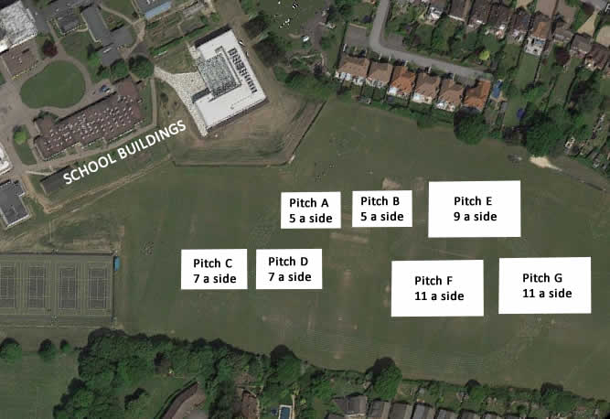

Directions:
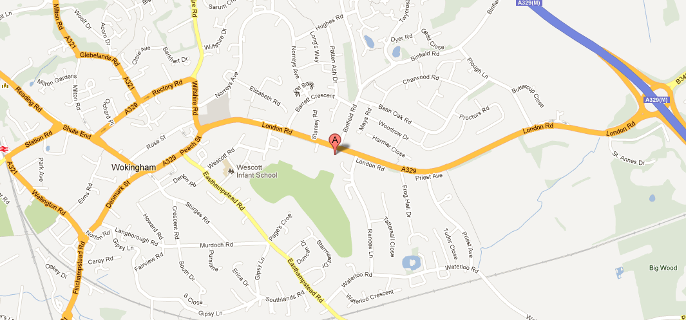
- From M3, Junction 3
- Take A322 north to Bracknell
- At Bracknell pick up A329M to Wokingham
- Follow signs to Wokingham, exit onto Coppid Beech roundabout, take first exit
- At traffic lights go straight
- School entrance is on the left
- Bear right in front of school and follow road round the side of the school
- Park on playground area before playing fields
- From M4 Junction 10
- Take A329M south to Wokingham
- Follow signs to Wokingham, exit onto Coppid Beech roundabout, take third exit
- As 1d above
- From Finchampstead
- Head for Wokingham town centre on A321
- Go under 2 railway bridges
- Take 2nd exit at Carnival Pool roundabout
- Go over first roundabout
- Next roundabout, at railway station, turn right
- Next roundabout, at Hope and Anchor, turn right
- Go left at traffic lights
- Go across next lights and into right hand lane, follow road round to the right
- Go into left hand lane and turn left by the church
- School entrance is on the left after the Sports Centre
- As 1f above
- From Winnersh/Woodley/Earley
- Follow A329 to Wokingham
- At roundabout (Shute End) by Council Offices go straight across
- As 3g above

Ashridge Park First Aid – Emergency Action Plan

1. Each team has a qualified first aider. All Managers and Coaches must ensure they have an up to date certificate or recognised qualification, ie less than 3 years old. Ensure that you are aware of all your players’ pre-existing medical conditions.

2. Each team has an up to date first aid kit that is kept fully stocked. The kit must be available at training and games

3. There must always be at least two adults present with a mobile phone at training sessions and games.

4. The pitch should always be inspected before training or a game commences for any sharp objects/broken glass or anything else that could cause injury.

5. Be familiar with your surroundings. Know the full address where you are playing including the post code. These are the details for our home games:

St Crispins School Cantley Park
London Road Twyford Road
Wokingham Wokingham
RG40 1SS RG40 5QG

Ensure access to the pitch is available for an ambulance, i.e. Respect Boards/barriers/cones are in place and gate not padlocked.

If you need to call an ambulance, please dial 999. Avoid the 101 Service.

6. Know where the nearest hospital to the ground you are playing at is.

Royal Berkshire Bracknell Clinic
Eastern Gate,
Brants Bridge,
Bracknell,
Berkshire,
RG12 9BG

01344 662900

7. If you have to treat a player for an injury that requires Hospital Treatment, then keep a note of the details, time, and what happened for future reference. Please forward the details to the Club Secretary.

8. Limit your first aid treatment and /or advice to the knowledge and practice in which you are formally trained. Carry and use only medical items that you have been trained to use.

9. Protect yourself, others and the casualty. Do what is necessary to prevent deterioration of the player’s condition while awaiting the arrival of Emergency Services.

